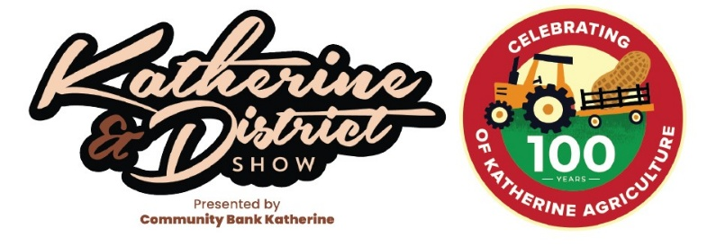
2026 Cattle Program
Judge: Lawson Camm of Cambil Brahmans, Proserpine QLD
Steward: Jessica Di Pasquale
Announcer: Maddi Harley
CATTLE REGULATIONS TO BE READ IN CONJUNCTION WITH GENERAL REGULATIONS
- Please fill in and submit the following Waiver to mail@katherineshow.org.au
- Entries must be the Bonafide property of the entrant.
- All cattle must have NILS tags and must be NLIS read prior to arrival at the Showgrounds and the files are to be emailed to joshua.haigh@nt.gov.au or 0467 740 233 for any information.
- All stock must have NT Waybills and this will be policed by DPIF inspectors.
- All stud cattle must be on the Showgrounds by Wednesday 15 July.
- The age of all stud cattle shall be the actual age as at 30th June of the current year.
- Dust coats must be worn while leading cattle in the judging ring.
- Winning exhibits in Led Classes must enter the Grand Parade on Friday 17 July
- Cattle must remain on the Showgrounds until 2.30pm on Saturday 18 July. Can remain longer, fireworks are Saturday night.
- Exhibitors must make arrangements with the Regional Veterinary Officer regarding the health status and legal requirements for the movement of cattle.
- Bedding hay will be provided by KDSS. Cattle are stalled in pens.
- All Stud Class Bulls and Females must be registered pure bred. Proof of registration is required.
- Any female with a calf at foot competing in a class, shall not be accompanied by the calf where the calf is competing in a class of its own, or where the calf is over six months old.
- All animals, male and female, over 12 months of age must be ringed or dogged when being led/handled on the Showgrounds. This rule will be enforced even if it means abandoning the class.
- The Stewards will note handling ability and may take out any unruly beasts.
- The Steward is responsible for the smooth flowing of the show and their decision is final.
- The Society may order a veterinary inspection as and when it deems necessary.
- Junior paraders and judging classes - The handler need not compete in any other class and may lead any breed. The judging classes are an opportunity for people to display their judging ability. Entrants do not need to bring anything. Winners of this event are eligible as NT Representative.
- Unled Cattle - These cattle will be penned and are not eligible to enter the led classes.
- Special Classes - Judged on the following: Total professionalism of groom/handler throughout the duration of the show; points awarded for positive attitude (e.g. helpfulness, politeness), interaction with the public and other competitors and officials, presentation of their animals and pens, correct attire etc. Open to all cattle attendants. No need to nominate, judged over the duration of the show.
- For information regarding classes call Steward Jessica Di Pasquale 0400 258 048.

Order of Events
Wednesday 15 July
Cattle to arrive at grounds.

Thursday 16 July
10am – Judging of penned stud and commercial classes.
Stud
L17 – Unled stud bull, any age (single animal)
L18 – Unled stud female, any age (single animal or cow/calf unit)
Commercial
L30 – Unled bull, any age (single animal)
L31 – Pen of 3 grower heifers 180-270kg
L32 – Pen of 3 feeder heifers 270-340kg
L33 – Pen of 3 grower steers 180-270kg
L34 – Pen of 3 feeder steers 270-340kg
Special Awards
Adrian Creighton Memorial Best Pen of Cattle
John Dyer Best Penned Bull

Friday 17 July
9am – Judging of led stud and commercial classes.

Stud Brahman Classes
Junior Female:
L01 – Heifer, 6 months & under 9 months
L02 – Heifer, 9 months & under 12 months
L03 – Heifer, 12 months & under 18 months
L04 – Heifer, 18 months & under 21 months
Champion/Reserve Champion Junior Heifer
Senior Female:
L05 – Heifer, 21 months & under 24 months
L06 – Cow, 24 months & under 36 months
L07 – Cow, 36 months & over
Champion/Reserve Champion Senior Cow
Grand Champion Female
Junior Bull:
L08 – Bull, 6 months & under 9 months
L09 – Bull, 9 months & under 12 months
L10 – Bull, 12 months & under 18 months
L11 – Bull, 18 months & under 21 months
Champion/Reserve Champion Junior Bull
Senior Bull:
L12 – Bull, 21 months & under 24 months
L13 – Bull, 24 months & under 36 months
L14 – Bull, 36 months & under 48 months
Champion/Reserve Champion Senior Bull
Grand Champion Bull

Special Classes:
L15 – Breeders Group (Consisting of three animals bred by exhibitor, both sexes to be represented, one group per exhibitor)
L16 – Progeny Group (Consisting of three animals by the Dam or Sire, both sexes to be represented)
Commercial Classes
Led:
Junior Female:
L19 – Heifer, 6 months & under 12 months
L20 – Heifer, 12 months & under 21 months
Champion/Reserve Champion Junior Heifer
Senior Female:
L21 – Heifer, 21 months & under 24 months
L22 – Cow, 24 months & under 36 months
Champion/Reserve Champion Senior Cow
Grand Champion Female
Junior Bull:
L23 – Bull, 6 months & under 9 months
L24 – Bull, 12 months & under 21 months
Champion/Reserve Champion Junior Bull
Senior Bull:
L25 – Bull, 21 months & under 24 months
L26 – Bull, 24 months & under 36 months
Champion/Reserve Champion Senior Bull
Grand Champion Bull
Supreme Led Exhibit of the Show (Grand Champions from both stud and commercial classes)
Steer:
L27 – Steer, 6 months & under 12 months
L28 – Steer, 12 months & under 24 months
Novelty:
L29 – Best dressed poddy

Saturday 18 July
8am – Judging of the junior paraders and junior judging
Junior Paraders’ Competition
L38 – Under 13yrs
L39 – 13yrs & under 16yrs
L40 – 16yrs & under 19yrs
L41 – 19yrs & over
Junior Judging Competition
L42 – Under 13yrs
L43 – 13yrs & under 16yrs
L44 – 16yrs & under 19yrs
L45 – 19yrs & over
Best Cattle Attendant
L35 – Under 13yrs
L36 – 13yrs & under 16yrs
L37 – 16yrs & over
Special Awards
Best Kept Exhibit
Up and Coming Award

